41. Implement a C Program Given a string - sort in alphabetical order

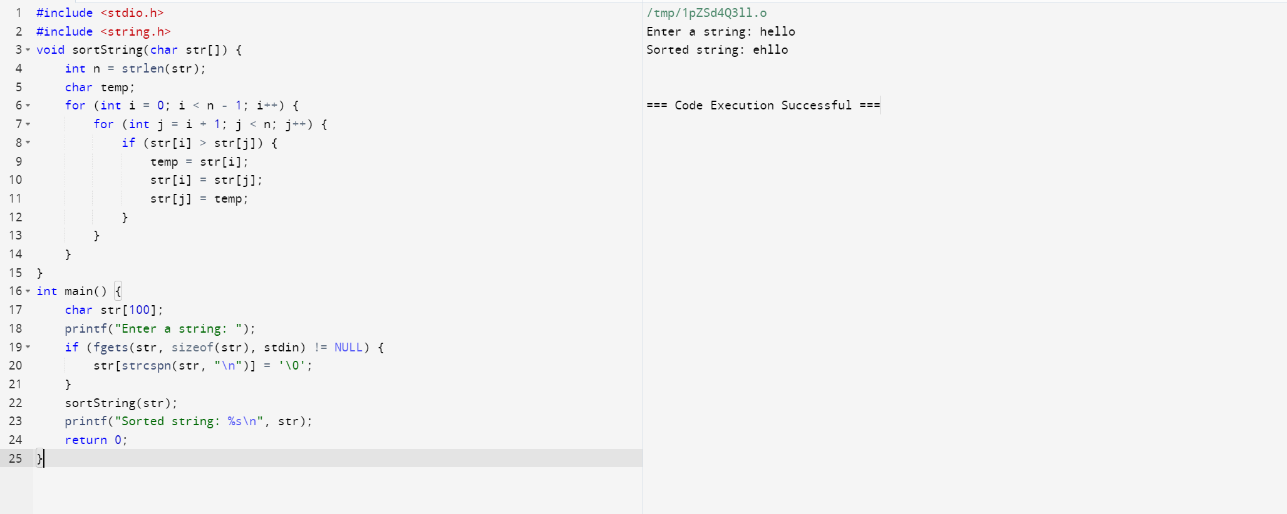

42. Implement a C Program to perform Bidirectional.

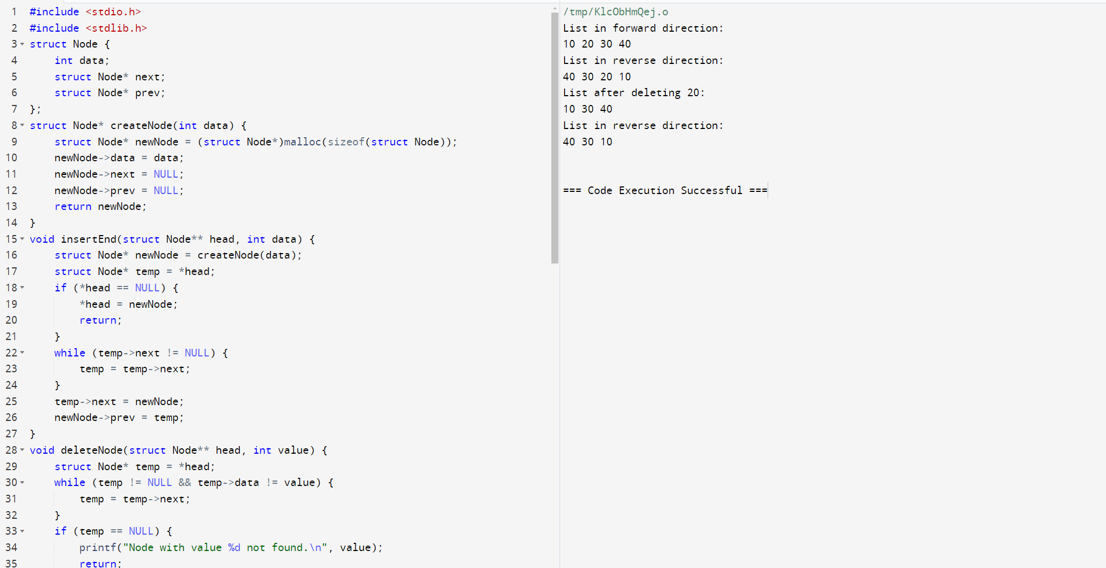

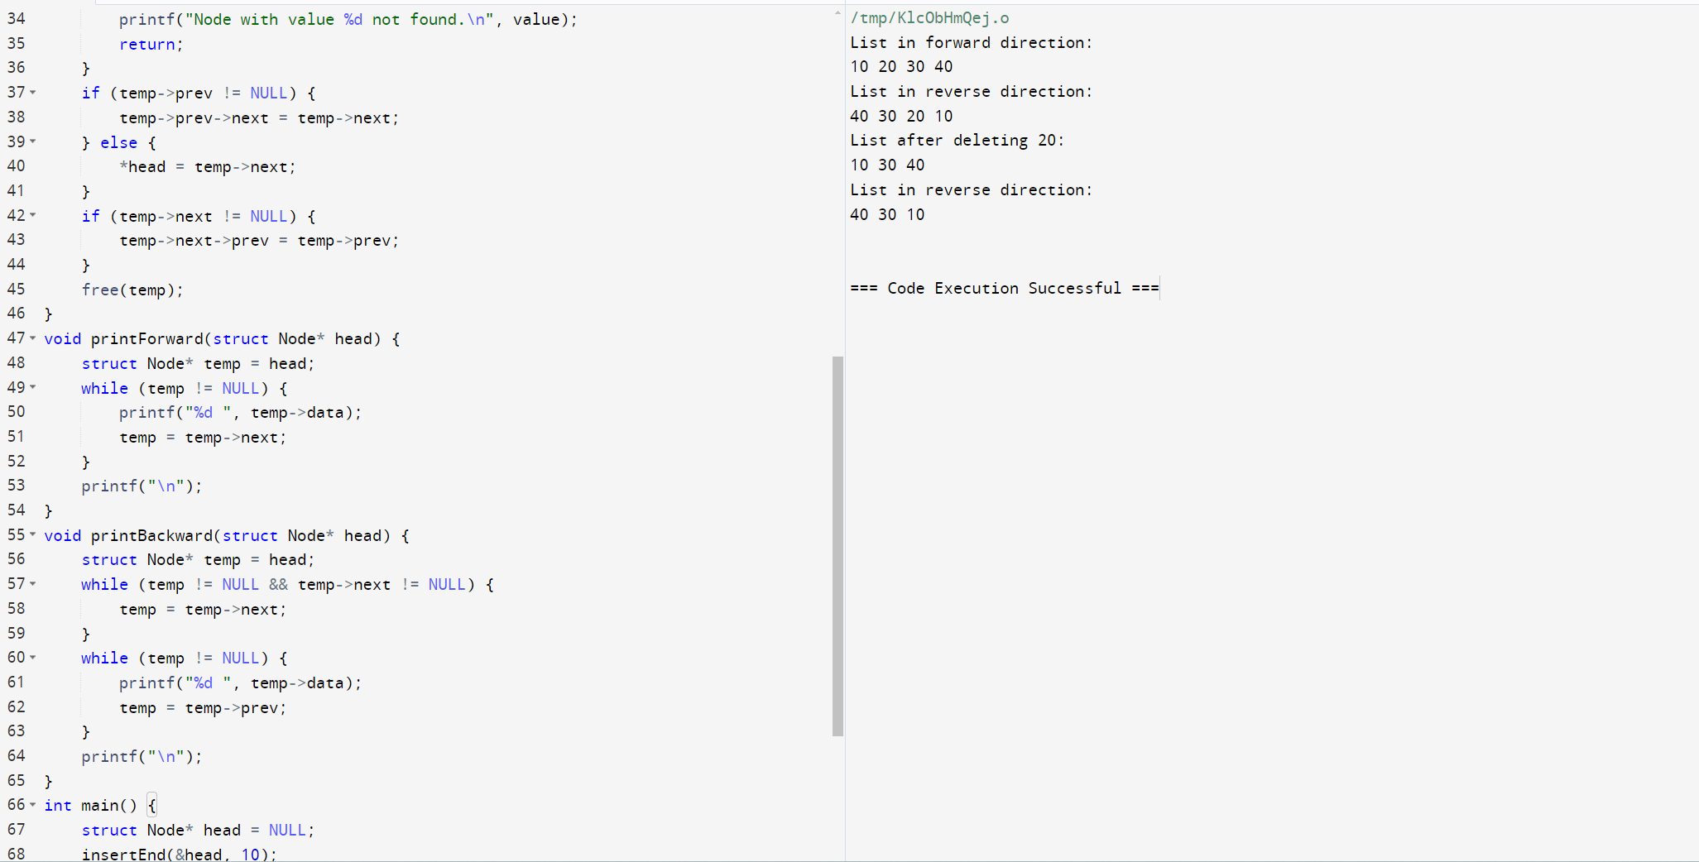

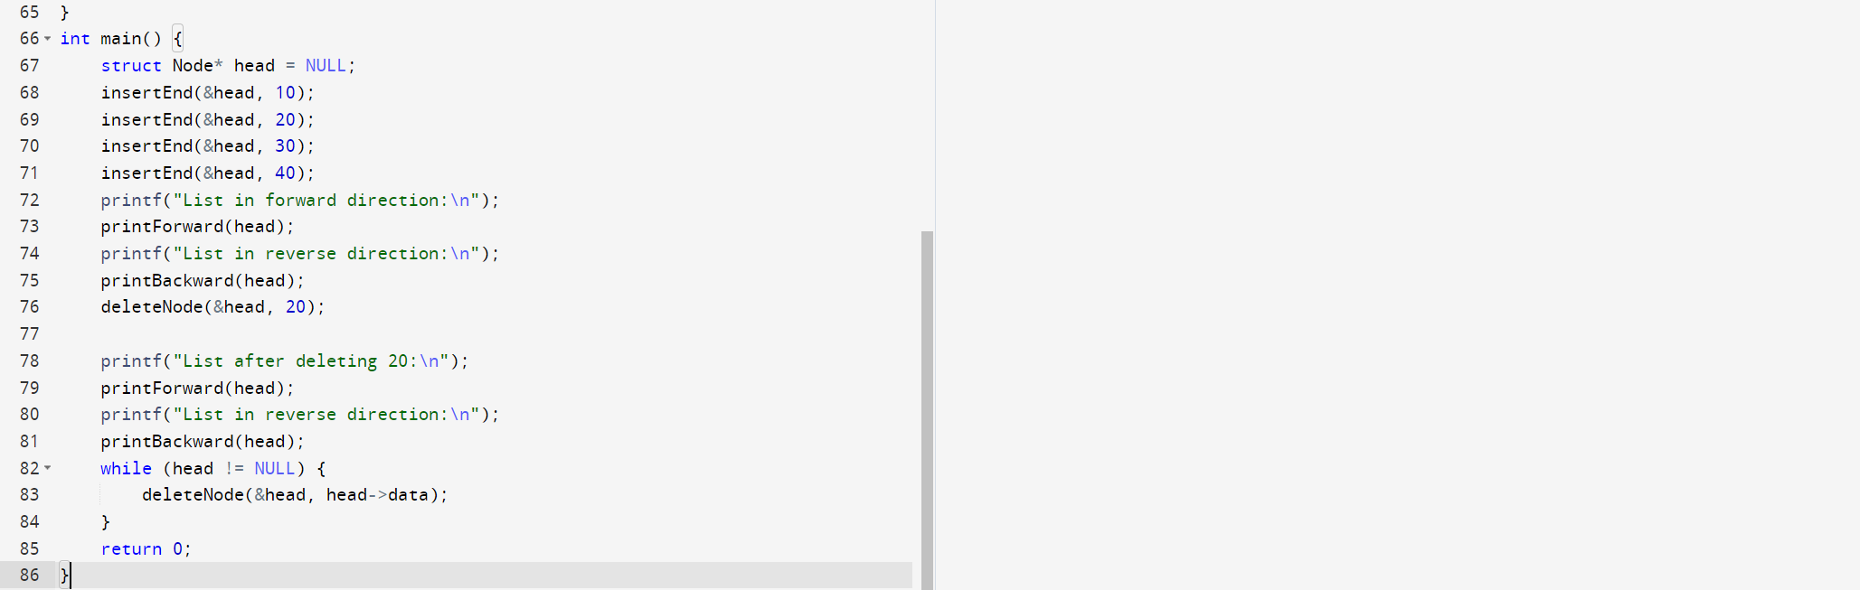

43. Implement a C Program to Print the frequently repeated numbers count from an array.

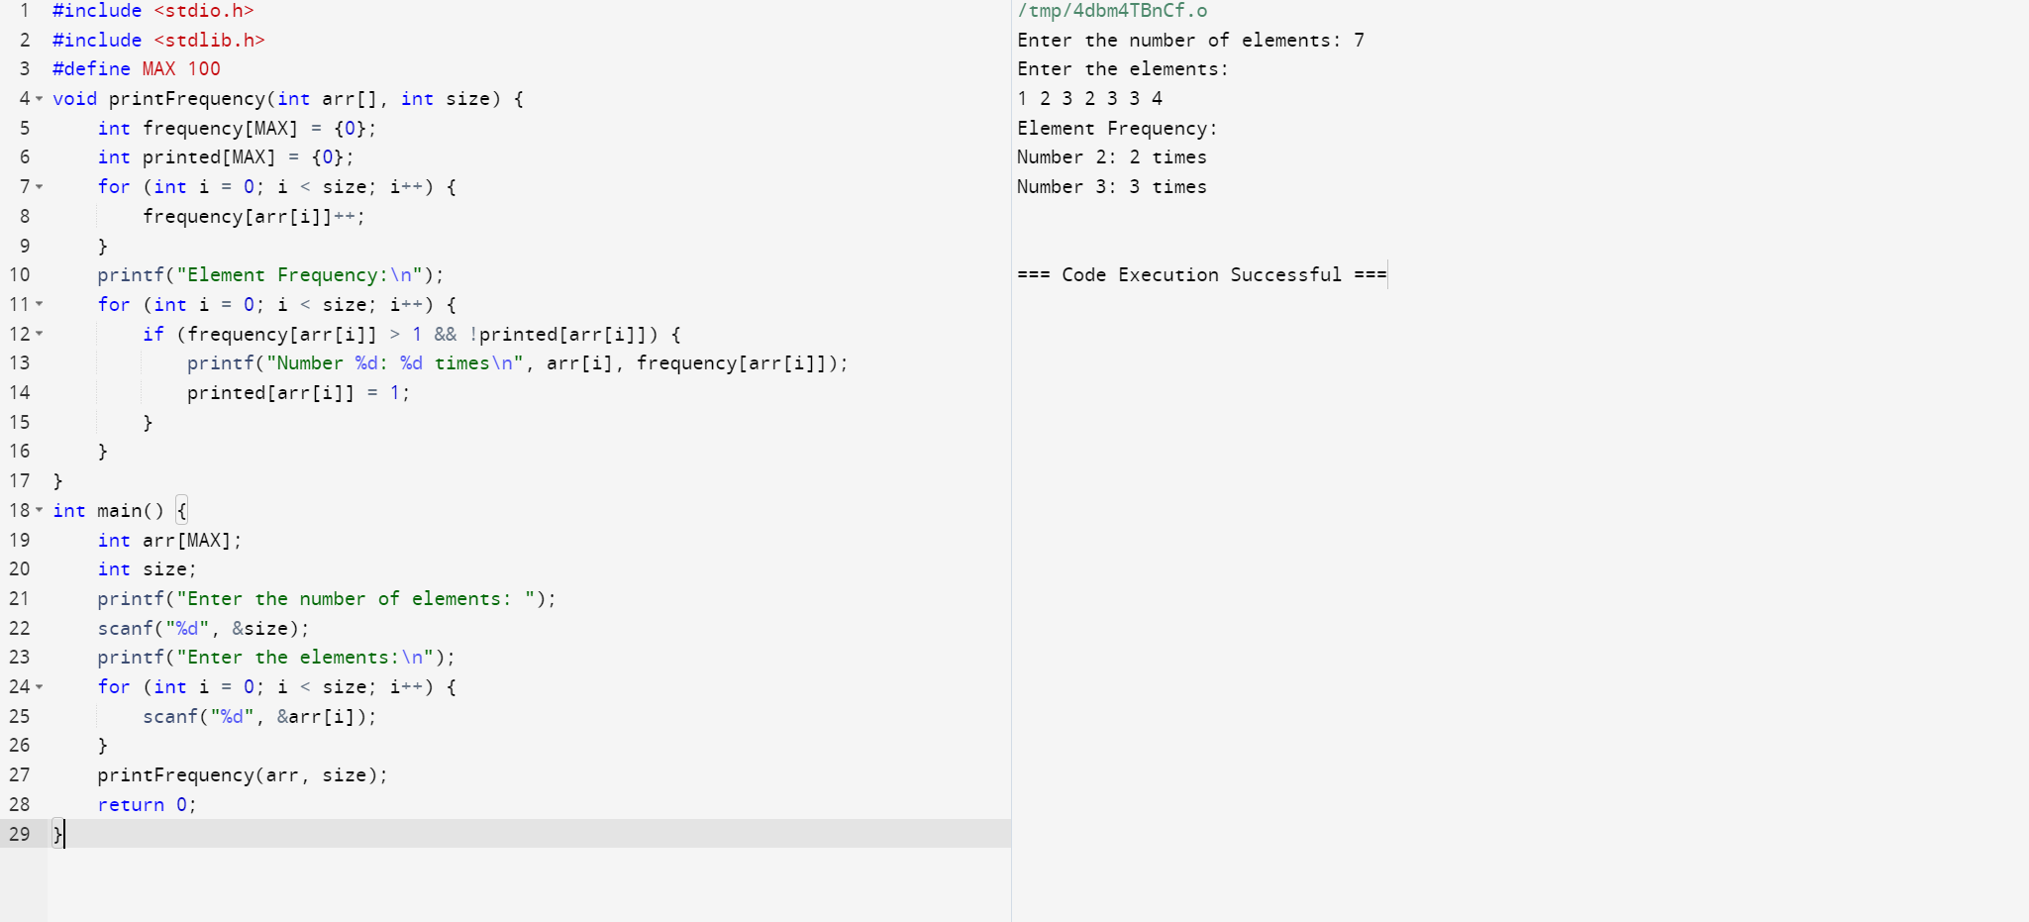

44.Implement a C Program to perform linked list – Deletion.

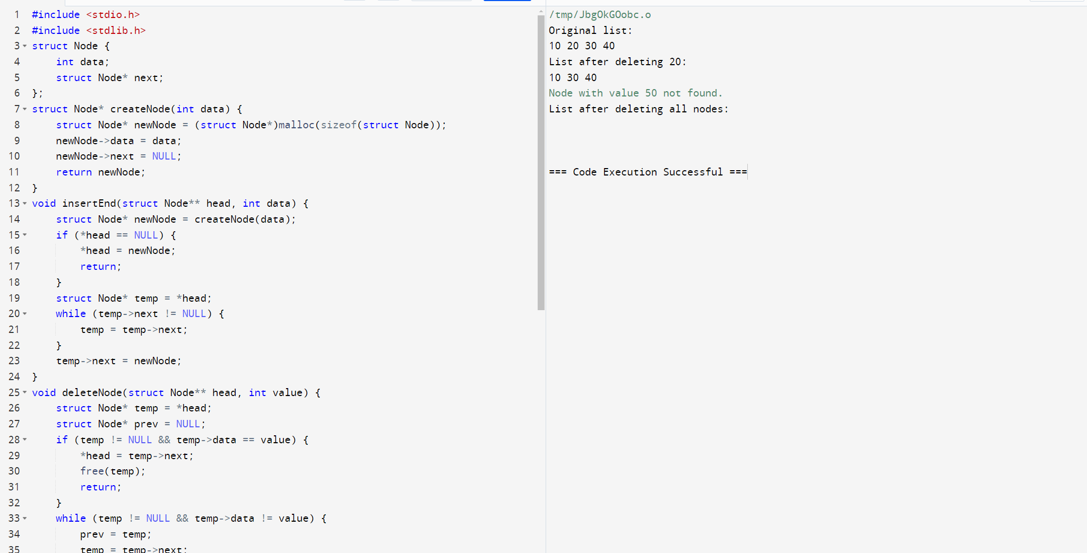

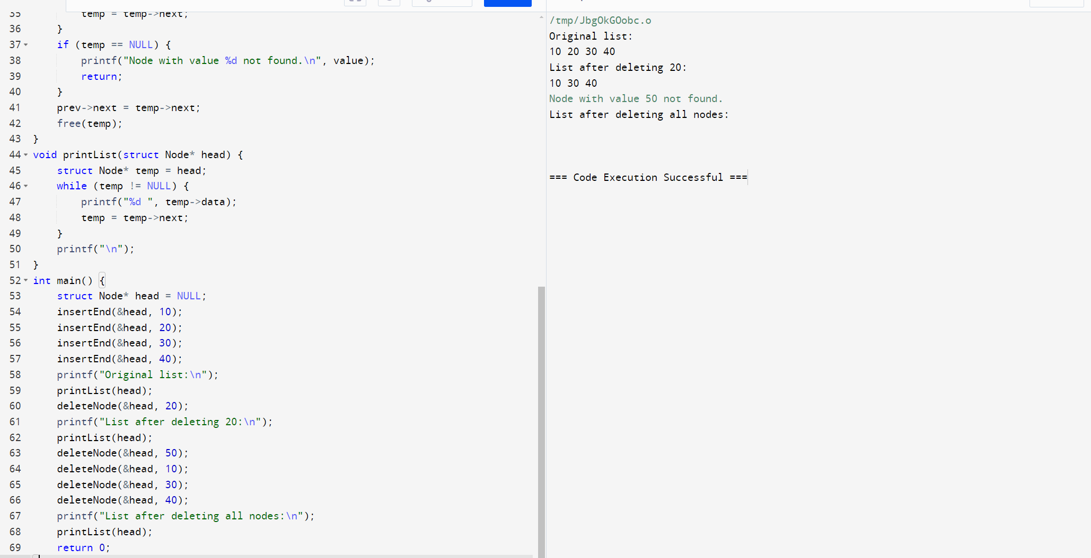

45. Implement a C Program to perform Sum of row and column in an Array.

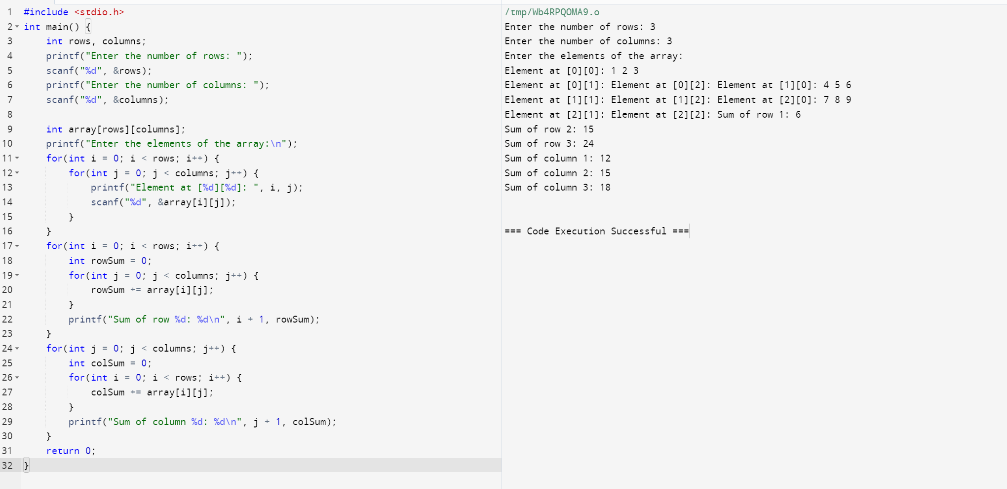

46. Implement a C Program to perform Tree traverse – Inorder.

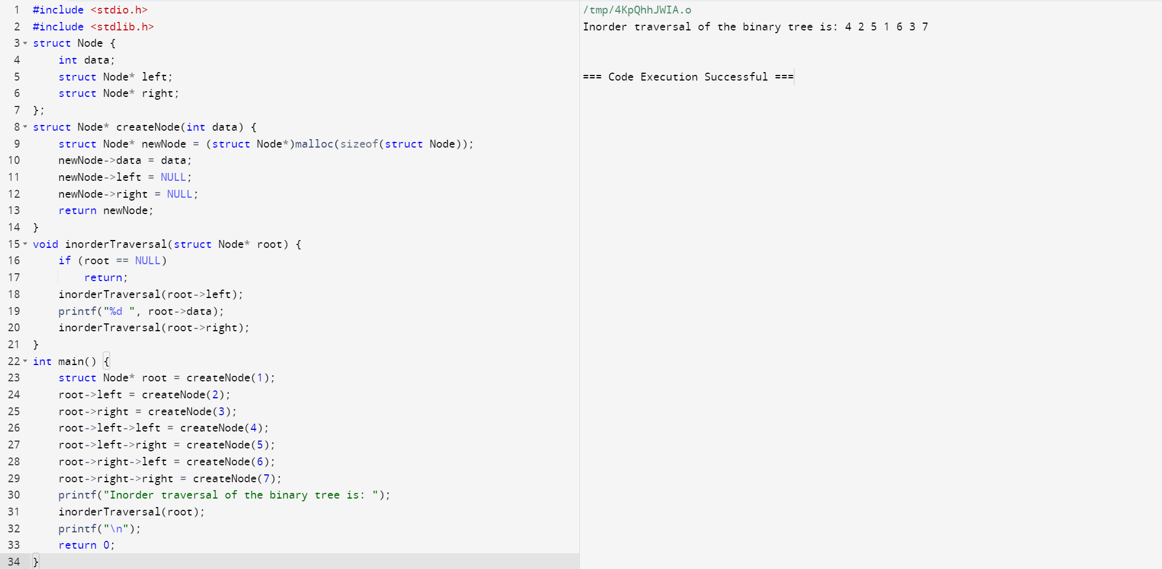

47. Implement a C Program to check for Elements repeated twice – Array

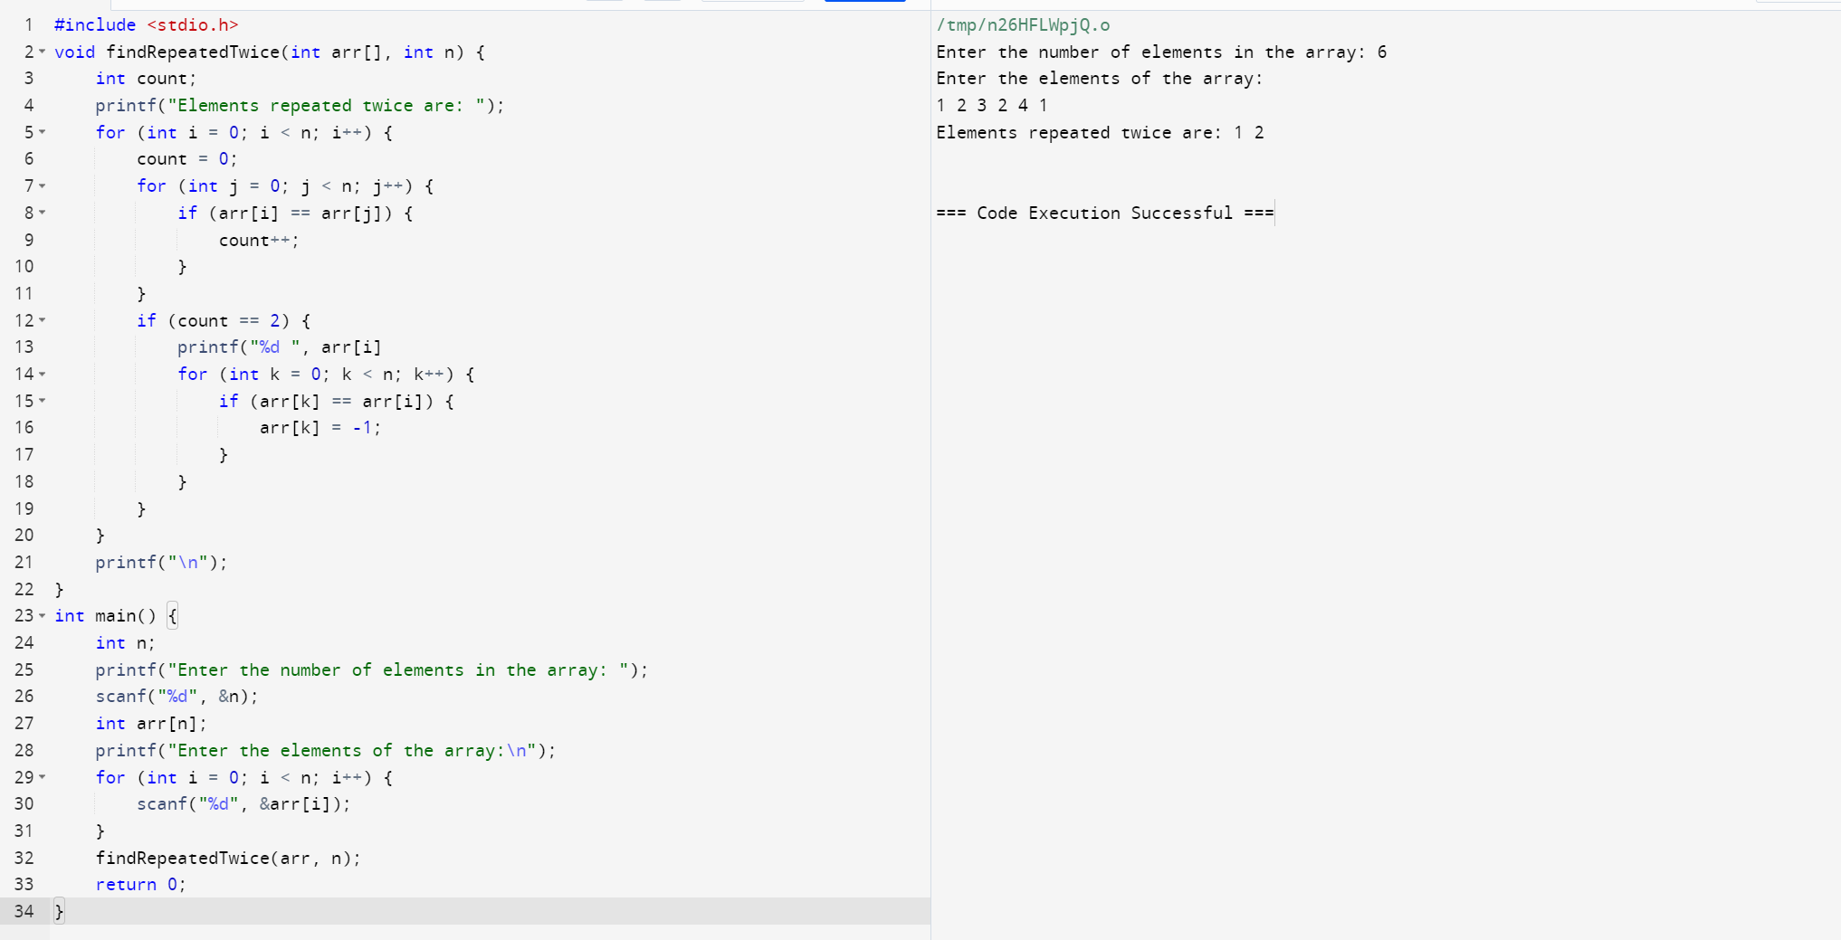

48. Implement a C Program for AVL tree – Insertion of Nodes.

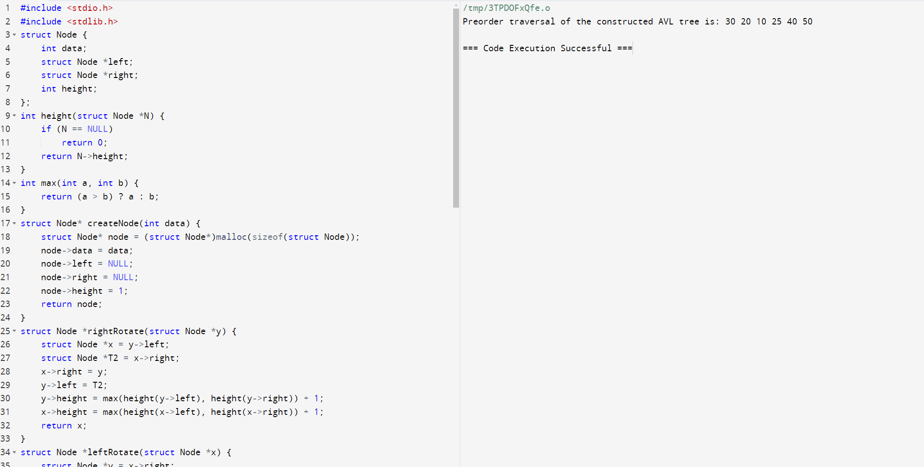

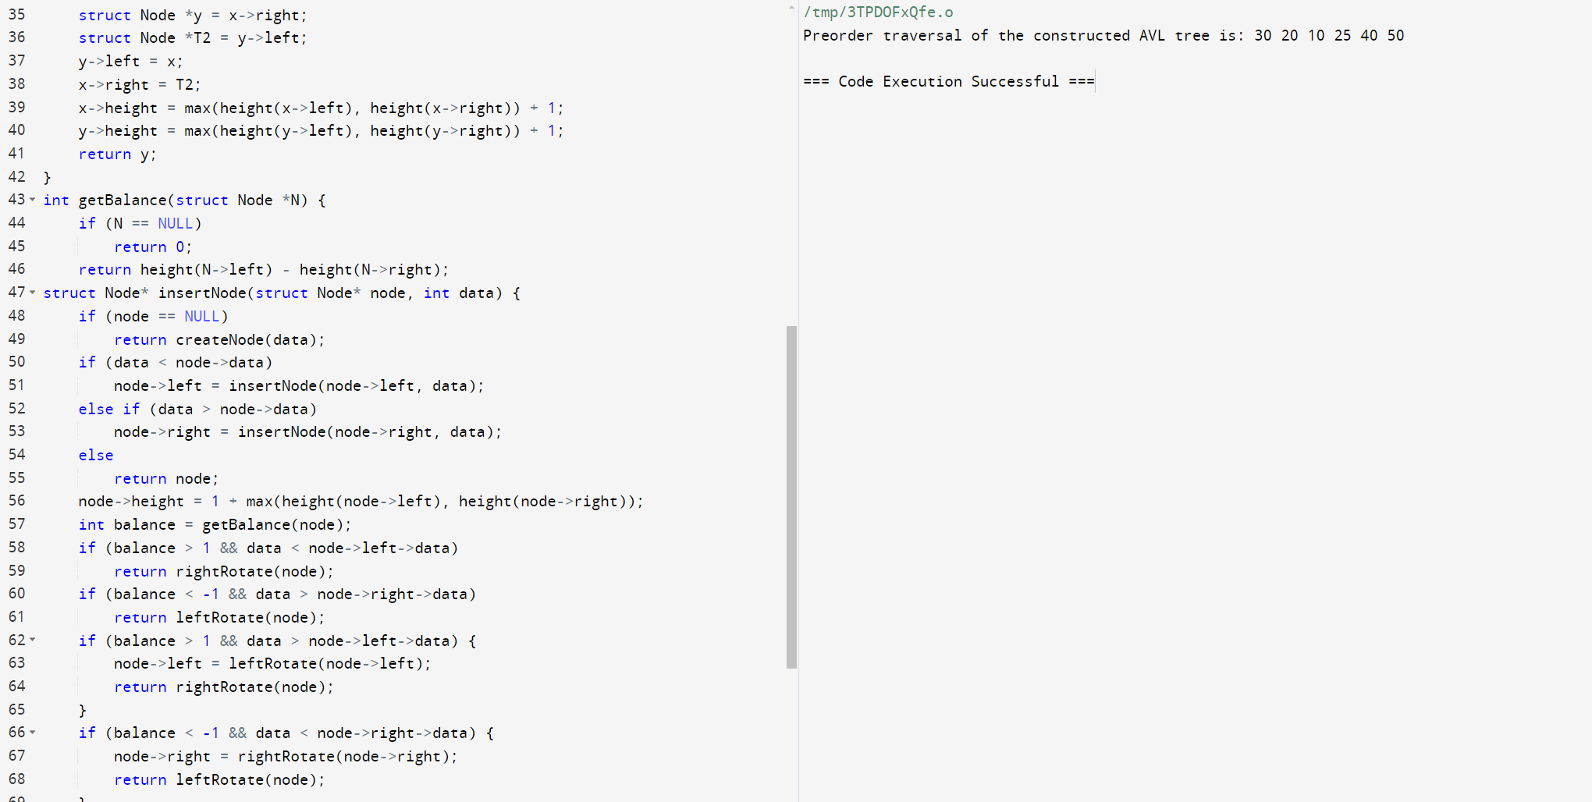

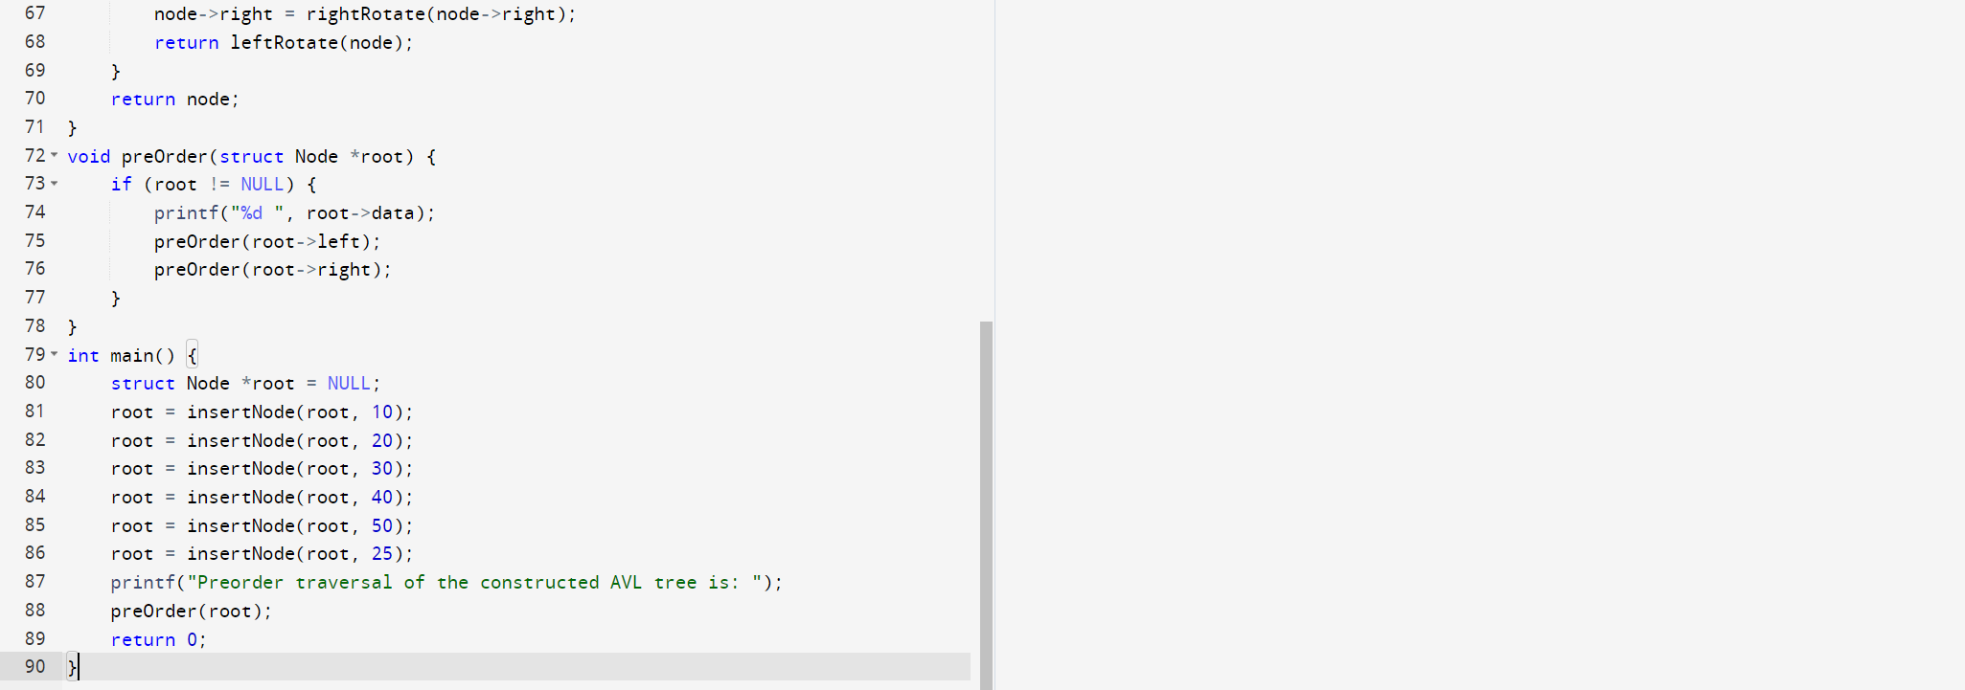

49. Implement a C Program Consider 2 stacks, add bottom most element and top

most element and print the value.

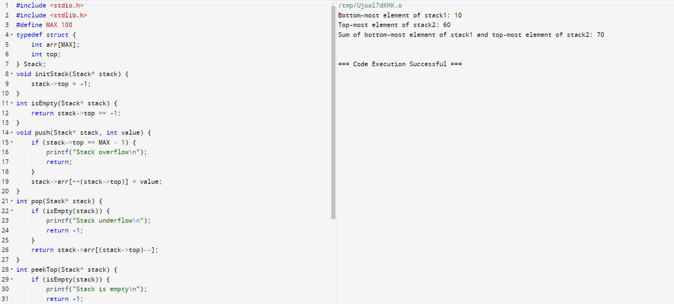

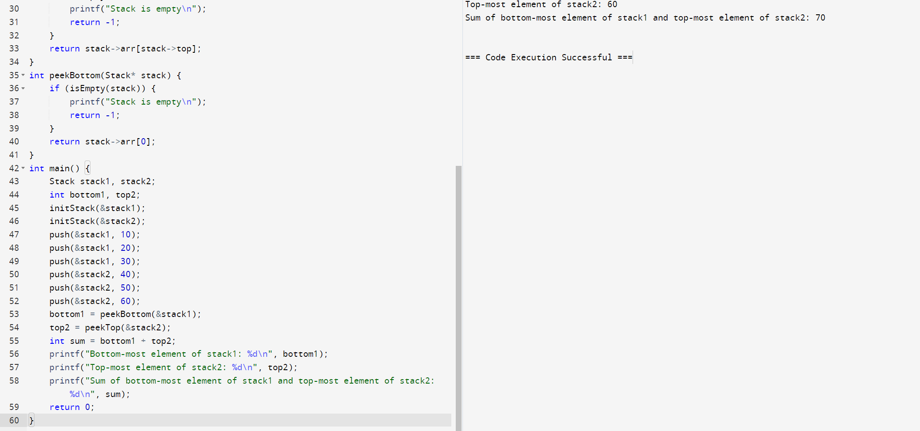

50. C program to print Factorial of a number without using Recursion.

